Department of Microbiology

484 West 12th Avenue
Columbus, OH 43210-1292

Phone (614) 292-2301
Fax (614) 292-8120

December 2, 2010

Professor Larry Krissek
Chair, Arts and Sciences CCI
Re: Geography Minor

Dear Professor Krissek:

At the November 29, 2010 meeting of the Mathematics and Social, Behavioral, and Natural Sciences CCI Subcommittee the semester conversion plans for the Geography Minor, submitted by the Department of Geography, was reviewed. This proposal presents an updated program for the minor. The new plan has removed the requirement for students to choose five courses from within one of four tracts and replaced this with an open plan. In the open plan students would choose five courses from any of the previously identified areas. It was stated that students choose the Geography minor for a wide variety of reasons and this new plan would better serve student’s specific interests and needs.

Following our discussion, the subcommittee unanimously approved the proposal and we have submitted it for the next step in the approval process.

Sincerely,
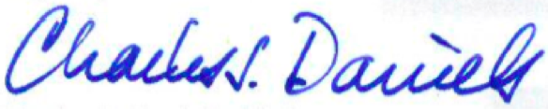

Charles J. Daniels, Ph.D.
Professor
Acting Subcommittee Chair for Nov. 24

